**EXPERIMENT 7**

**DQL COMMANDS (COLLEGE SCHEMA)**

**Aim:**

* Display student id and marks from the student table.

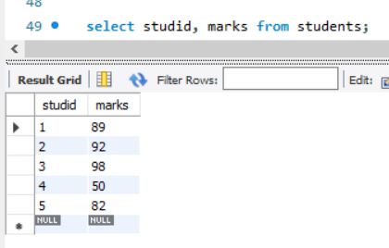

* Display faculty id and name from the faculty table.

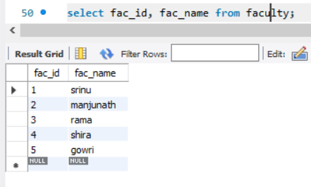

* Display who got grade A.

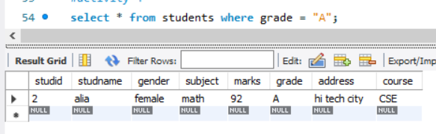

* Display whose marks are less than 50.

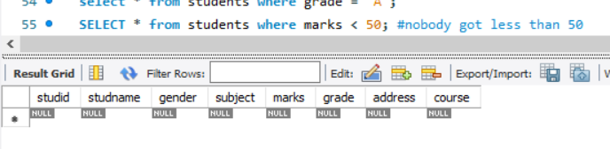

* Display the female students whose marks are between 50 to 60.

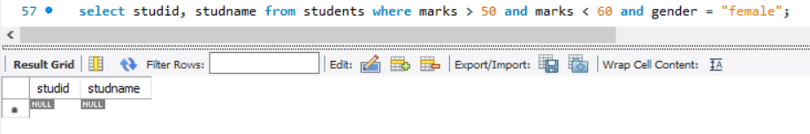

* Delete the failed students.





* Display activity id and name using object.

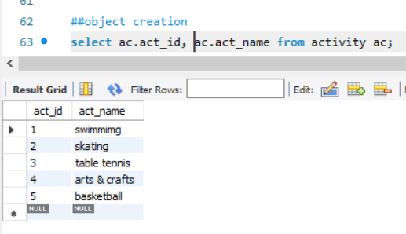

* Display student id, faculty id using course name condition with object.

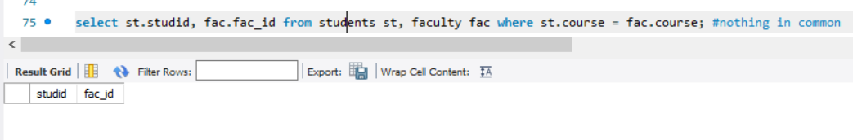

* Select department name starting from ‘c’ and faculty name ending with ‘ ’.

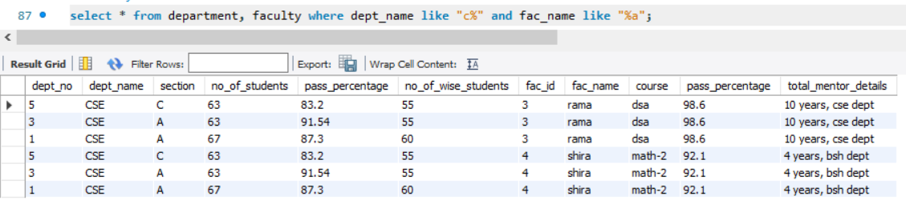

* Select activity having characters between ‘ck’.

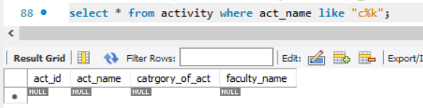

* Group by faculty id and display.

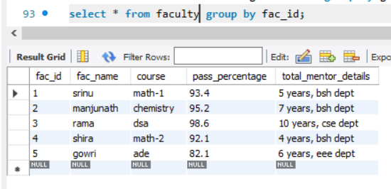

* Display the students list whose grade is A using having.

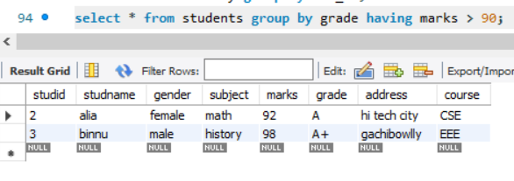

* Display the faculty list who are teaching PPS.

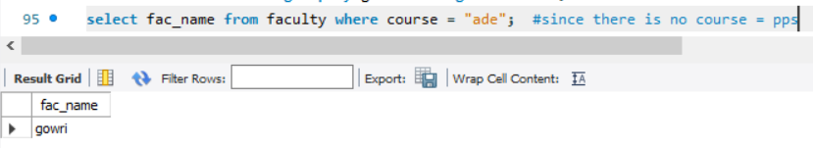

* Apply aggregate functions in student marks - max, min, sum, count, avg.

